BOOK WORLD PRAGUE 2014
20th INTERNATIONAL BOOK FAIR AND LITERARY FESTIVAL
Venue: Palace of Industry, Prague Exhibition Grounds (Holešovice)
Dates: 15th - 18th May 2014

B U L L E T I N

BOOK WORLD PRAGUE – BUSINESS CENTRE

Book World Prague would like to inform its professional guests about the Business Centre that will be located at the Industrial Palace, Middle Hall, for the entire duration of the book fair. Professional visitors are welcome to use the Business Centre free of charge for the purpose of negotiations, conducting business meetings and discussing international rights.

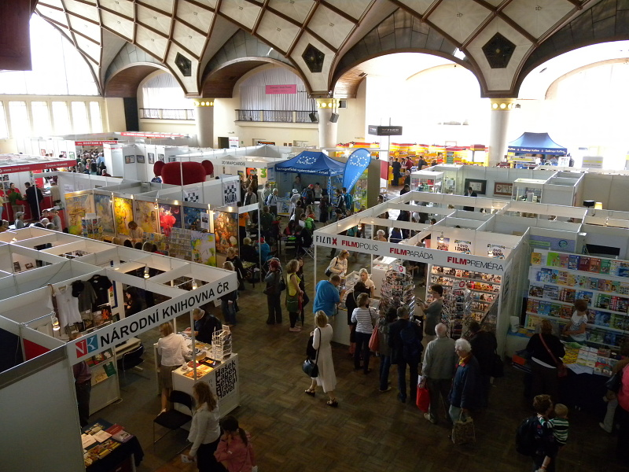
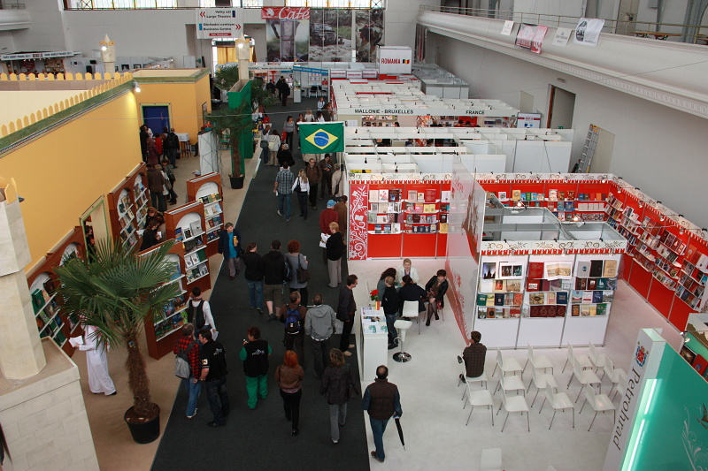

What does the Business Centre offer?

- A quiet, pleasant environment away from the hustle and bustle of the fair that allows for professionals to meet new and existing contacts and to negotiate potential business deals.
- The Business Centre is also a Right’s Centre and so offers the opportunity to discuss international copyright issues with other professionals from the Czech book market as well as other international visitors.
- It provides an opportunity to meet with a wide variety of professionals in the Czech book market, for example publishers, literary agents, distributors, booksellers and others.
- A cost-effective way to do business as Book World is offering a table at a low price for professional guests to use in the Centre.
- Free internet access is available to enable the visiting professional to keep in touch with the office.
- Pre-marketing and B2B support; we can assist the visiting professional by recommending appropriate contacts in the Czech book market as well as helping to arrange meetings before the fair.
- Assistants (Czech and English speaking) working at the fair can refer you to relevant publishers and assist in the arranging of meetings during the fair.
How to book space in the Business Centre
Professional visitors can book a table in the Business Centre for a specific day and time. Simply complete the attached form for registration as a professional visitor and return to info@svetknihy.cz.

Please note that this is an area exclusively designed for use by professionals to conduct business and is not open to the public.

Display of titles with copyright available

Those professional visitors who are attending the fair we would like to invite you to take advantage of our offer to participate in the Business Centre by choosing up to five (5) titles, with copyright available, to be displayed in the Centre. Display here ensures that your books will be seen by other professionals within the book market who are interested in making contacts. For a fee of 5,000 CZK (excluding VAT) we can offer:

- Shelf space to accommodate five (5) books with copyright available.
- Display of your company sign and website.
- Assistants (Czech and English speaking) working at the fair will introduce the titles according to your instructions and distribute any promotional material related to your books to professional guests.
- Entry into the Exhibitors Catalogue which is distributed to exhibitors and visitors at the book fair.
- Entry into the online WHO IS WHO catalogue on www.bookworld.cz; an excellent resource providing the contact details of publishers and other professionals to allow people to make contacts and arrange meetings.
- Pre-marketing and B2B support; we can recommend appropriate contacts in the Czech book market and help you to arrange meetings before the fair. Please note that this offer is only available for professionals attending the fair.

For international publishers who cannot attend Book World Prague this year we would like to extend this offer to you so that you may send us five (5) books to be displayed at the Business Centre in order to ‘try the market’. Along with the above offer we can also provide you with a follow-up service so that any relevant contact data collected throughout the fair will be forwarded to you. Unfortunately we are unable to return the books sent to us for this service.

To book space in the Display
If you are interested in displaying your books in the Business Centre then please complete the form we can provide you with and return to info@svetknihy.cz before the 15st of March 2014.

Statistics
The Czech book market is thriving; the number of books published per capita of population places the Czech Republic as one of the world’s leading nations in terms of book production with 17, 247 new titles published in 2012 including 4,684 fiction and 1,698 children’s books. Particularly worthy of note is the large amount of translated titles published in the same period: 5,871 from a range of languages. The previous year’s book fair attracted 339 exhibitors and held 192 stands from 24 countries and regions. There were 36,000 visitors in total of which 750 were professionals and 374 were members of the accredited press.

More information on what is available at the book fair and the programme of events can be found on www.bookworld.cz. To request a copy of the programme send an email to info@svetknihy.cz and once the programme has been finalised an email will be sent to you with the relevant information.

